Activity sheet 6.4 Stratigraphy
Can we use fossils to figure out which sediments were deposited first and which ones were deposited later?
Background
In the early 19th century geologists noticed that rock layers in different parts of the world could be correlated and matched because they contained the same fossils. This was at a time when they didn’t fully understand what fossils were. They used the pattern of fossils in different rock strata to identify their relative ages. Relative dating tells scientists if a rock layer is “older” or “younger” than another. This would also mean that fossils found in the deepest layer of rocks in an area would represent the oldest forms of life in that particular rock formation.
Instructions
Task 1 – Letter Cards
1. Working in small groups, cut out the eight letter cards and spread them on the desk in front of you. Each letter on these cards represents a different fossil.
2. The first (bottom) card in the sequence is TC. Hence the letters “T” and “C” represent fossils in the oldest rock layer. They are the oldest fossils, or the first fossils formed in the past for this sequence of rock layers.
3. Sequence the eight cards by comparing letters that are common to individual cards, and therefore overlap. Look for a card that has either a “T” or “C” fossil on it. Since this card has a common fossil with the first card, it must go on top of the TC card. The fossils represented by the letters on this card are “younger” than the “T” or “C” fossils on the TC card.
4. Sequence the remaining cards by the same process. When done you should have a vertical stack of cards with the top card representing the youngest fossils of this rock sequence and the TC card at the bottom of the stack indicating the oldest fossils.
5. Download the e-Notebook for Activity 6.4. Copy the sequence of letter cards with the TC card at the bottom of the stack into your e-Notebook and answer questions 1 - 3.
Task 2 – Fossil Cards
1. Cut out the eight Fossil Cards. Each card represents a particular rock layer with a collection of fossils that are found in that particular rock stratum. All of the fossils represented would be found in sedimentary rocks of marine origin.
2. The oldest rock layer is marked with the letter “M”. Put it at the bottom of the stack.
3. Look for a rock layer that has at least one of the fossils you found in the rock layer “M”. This rock layer would be younger as indicated by the appearance of new fossils in the rock stratum. Keep in mind that extinction is forever. Once an organism disappears from the sequence it cannot reappear later. Use this information to sequence the cards into a vertical stack of rock strata (stratigraphic column). Arrange them from oldest to youngest, with the oldest layer on the bottom.

4. When you have completed your stack, check your stratigraphic column with the columns developed by other students. Do you agree? If not, discuss where your version is different and try to agree on a structure. (Your teacher also has a version for you to compare with at the end.)
5. Answer discussion questions 4 - 5 in your e-Notebook.
This activity is similar to the work paleontologists do as they try to understand the deposition history of sedimentary beds they find in different parts of the world. This is known as Stratigraphic Correlation.

LETTER CARDS
TC | OXD
CA | UBN
AU | DM
BN | NO

FOSSIL CARDS
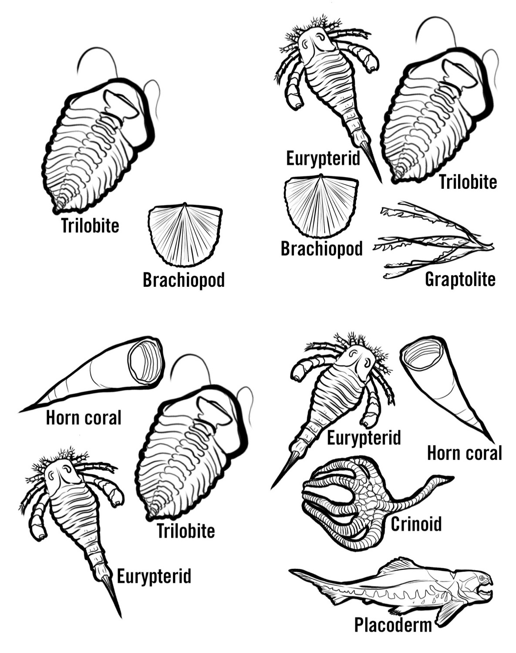 | 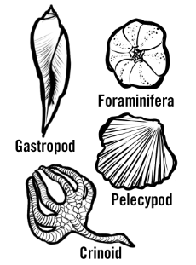  G
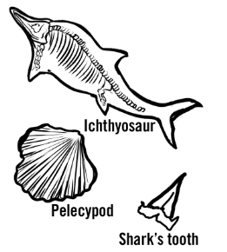  O  M | 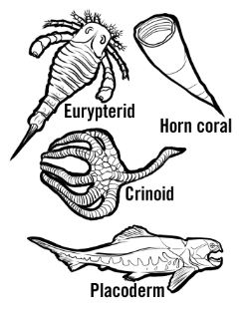  N

FOSSIL CARDS
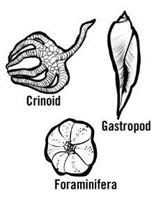  A | 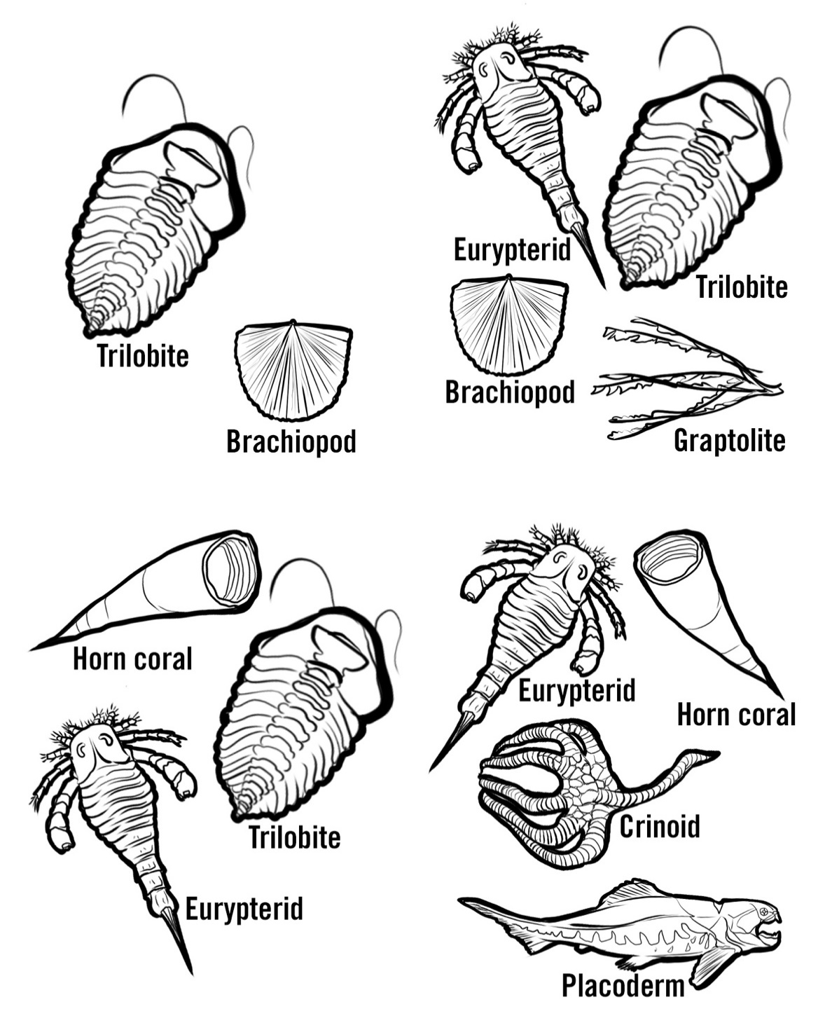  S
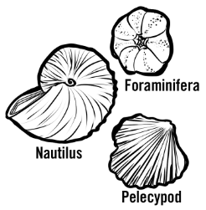  R | 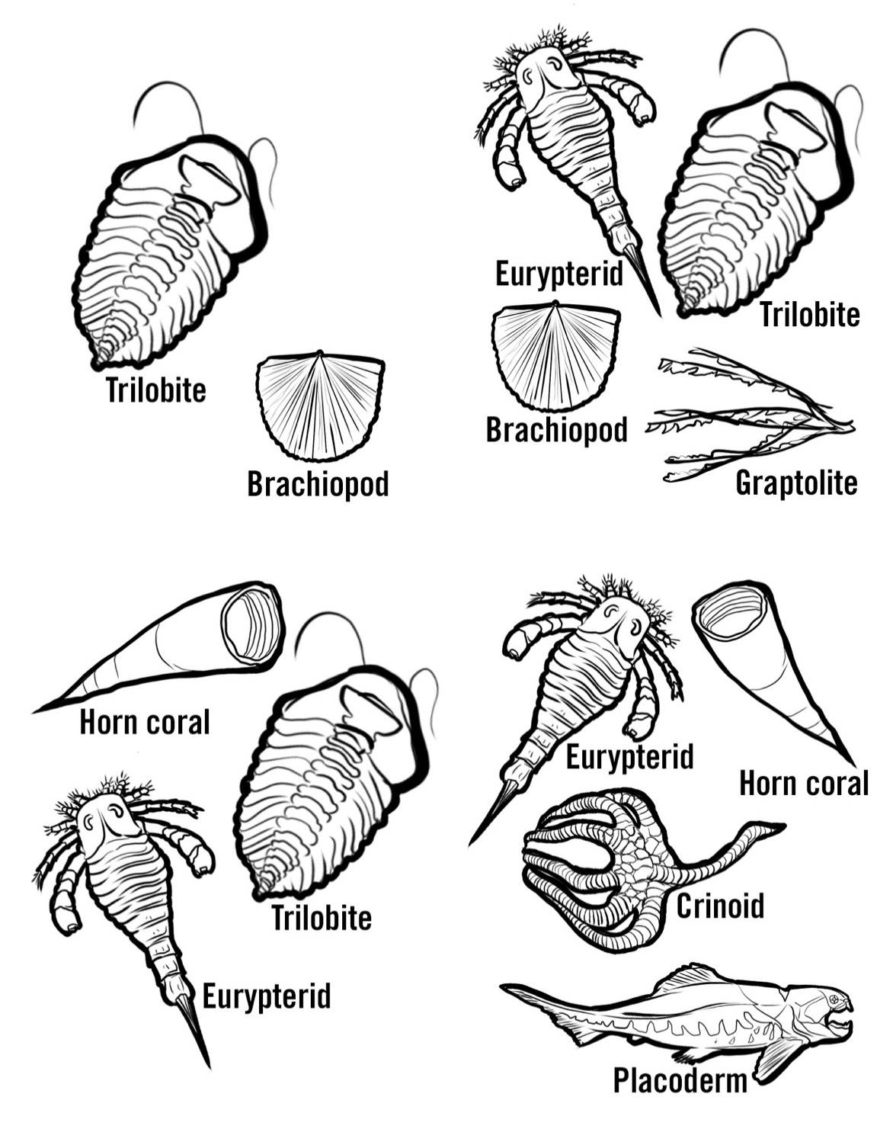  I

